1. Extract The Folder
2. Run backend.exe
3. Command prompt will open, copy to the given in command prompt

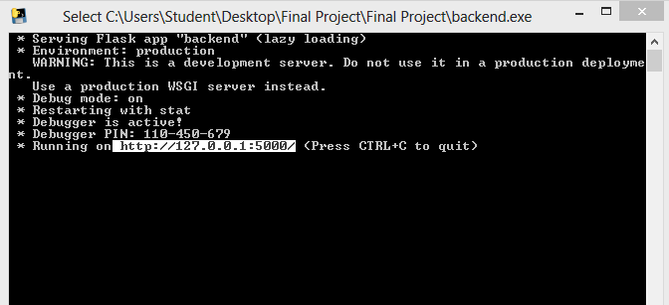

1. Leave username and password blank. Click login
2. Enjoy parking the car